Program Name: | CCMS
Project ID-Name:

Document Control

- Document History

Version | Date | Status:  <Draft/ Final> | Author | Comment / Changes from Prior Version
1.0 | 6-Jun-2012 | Draft | Dewan Ahsanullah | Initial Version

- Document Reviewers/Approvers

Name | Position (e.g. Client Manager, Project Manager etc.) | Reviewer (only) | Reviewer and Approver
Aminul Bari |  | X
Iftekhar Ahmed |  |  | X
Arifur Rahman |  |  | X

Contents
1 Summary of Functional Solution 3
1.1 The Business Problem/Need 3
1.2 Scope 3
2 Impact Analysis 4
2.1 Impact to Internal Interfaces 4
3 System interface Design 5
3.1 Overview on Changes 5
3.2 Inputs 5
3.3 Outputs 5
3.4 Processing 5
4 Human Interface Design 5
4.1 Overview and Navigation 5
4.2 User Interface 6
5 System Specification 6
5.1 Data Flow Diagram 6
5.2 Function Specifications 6
6 PERFORMANCE AND NON FUNCTIONAL Requirements 11
6.1 Volumes 11
6.2 Potential Growth 11
6.3 Performance 11
6.4 Exception Handling 11
6.5 Usability 11
6.6 System Availability 11
6.7 Contingency and Disaster Recovery 11
6.8 Help and Training 11
7 Information Security 11
7.1 General Information Security 11
7.2 Authorization and Access Control 12
7.3 Audit Logging and Alerts 12
7.4 Security Administration 12
8 Regulatory, Audit and Data Retention Requirements 12
8.1 Regulatory and Legal Requirements 12
8.2 Archiving / Data Retention Requirements 12
8.3 Control Requirements 12
9 Glossary of Terms 12
10 Appendices 13

Summary of Functional Solution

The Business Problem/Need

The software is designed to keep track of all collection information such as client deposit at different location, generate reminder, maintain billing, DD information and has an Interface between CCMS and their global software to facilitate automatic transactions.

CCMS will maintain following products:

- CitiSpeed
- CitiCash
- CitiCheck
- NormalCollection.

CCMS capture data which is deposited at different location. Deposit amount are collected on Deposit slip. Amount on deposit maintain in the system.

Scope
Below products will maintain in the CCMS

Citispeed

Citispeed is the product of Citibank which comprises only check information that is collected by coordinator from different location. Customer Check at different location are collected by coordinator and Deposit these checks to Correspondent bank in which Citibank has an account .These checks are honored through clearing house of that location. After getting these check information on deposit slip input are given to CCMS.

Citicash

Citicash is the product of Citibank which keeps track of deposited cash by their customer at different location. System maintains information of Customer cash amount deposit in Correspondent bank at different location which is collected by coordinator.

CitiCheck

Citicheck is the product of Citibank which comprises only check information that is collected by coordinator from different location, under clearing zone. After getting these check information on deposit slip input are given to CCMS. Check deposit at Citibank which is drawn on bank-branches at different location is send to the branches for collection.

Normal collection

Citicheck whether is returned or not, this is to be maintained by normal collection. If returned then what was the reason for returning, system maintains these information through normal collection. CitiCheck drawn on a location which is under clearing house are Normal Collection.

DD Information

CitiCheck which is drawn on a location which is not under clearing house are sent to local bank as DD .This DD information are maintained in the system. Information that has already been given input to CCMS is prepared for CCMS Subsystem for clearing.

Interface with different system

A text file contain daily collection amounts are generated from the software for other system like (IBBS, FlexCube) to upload which will credit sundry account and debit corrbank account. This is called booking process .During the file process it checks holiday and prepare data for reversal.

Daily deposit amount pass to IBBS for booking. It credit Bangladesh bank account and debit sundry account. And prepare data for reversal. Every thousand file generation the filename will be initialized and starts from “7000”.
All the clients must maintain their Cash credit day, check credit day, Cash Credit type, speed Credit type. Get max Seq. no from dschedule. Get Batch no for filename. Generate refno starts from “0000000001”. Prepare credit data. Prepare Booking Data. Separate citicheck amount which value date will be less than todate. And Citicash amount of today. And check holiday and make reversal date of each record. Sort all data according to “cash” and “check” wise. Update refno for each record. Now select all data which are check and prepare data for debit. Prepare debit data for cash it like preparing check. After prepare all data generate booking file. Update reference no in master table.

Another process generates a text file to debit sundry account and credit customer account which is called reversal.

Reminder

Reminder is sent to different bank at different location mentioning the check information which is not sent by those bank within given times. The time is set by the reversal process considering holiday and customer wise predefined time. Reminder generated for different banks to do either of the following: to sent by demand draft payable at Dhaka city or to return the dishonored check immediately.

Billing

End of month bill is prepared for customers regarding services provided by Citibank. Charges are maintained customer wise. As per agreement with customer, Cash and check charges are defined, also it consider return charges, Courier charges, Bangladesh bank charges ,VAT and other charges. Finally a monthly bill is prepared for each customer considering mentioned criteria.

Impact Analysis

Impact to Internal Interfaces

Impact on Front-end
- Check entry screen to capture all check detail information.
- Generate Booking and reversal FlexCube Uploadable file
- Generate Billing report
- Generate reports

Impact on Back-end
- Processing Flexcube uploadable file
- Process Billing
- Processing Normal collection funding report
- AES report

Impact to External Interfaces

- Generate A/C entry file for Flexcube
- Generate AES reports

Risks and Assumptions

- If any incorrect information is found during check detail entry then user can correct the information from the check Entry form.

System interface Design

Overview on Changes

Inputs

- Parameter maintenance
- Maintain collection check details
- Maintain DD information

Outputs
- Generate Booking & reversal files for flexcube
- Generates various reports for MIS.
- Generate reminder for outstanding checks
- Generate AES reports

Processing
Check detail entry to capture all Collection check information.
System will run process for booking and reversal file for Flexcube A/C file generation.

Human Interface Design

Overview and Navigation

N/A

User Interface

- Parameter maintenance
- Maintain clearing check details
- Generate reversal files for FlexCube
- Generate reminder for outstanding checks
- Generate DD information from CCMS
- Generate various reports for MIS.

System Specification
(Topic Heading – no input required here)

Data Flow Diagram

Work Flow & Data Flow of CCMS:

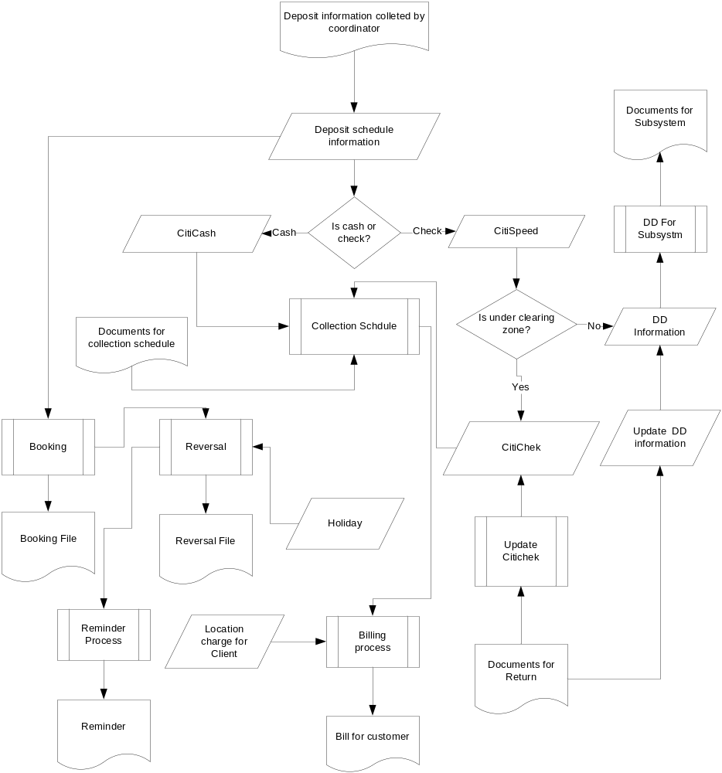

Function Specifications

Parameter Maintenance
BRD Req #
Detailed Description
System is required to keep below information as a parameter which will be used to capture check detail information

- Client Information
- Bank Information
- Branch Information
- Correspond Bank Information
- Location Information
- Zone Information
- Reject/Return Information
- Entry Location
- BBK Account Information
- Holiday Information
- Location Charge
- Deposit Schedule Stock

Check Entry
BRD Req # | NA
Detailed Description
Citibank which comprises only check information that is collected by coordinator from different location. Customer Check at different location are collected by coordinator and Deposit these checks to Correspondent bank in which Citibank has an account .These checks are honored through clearing house of that location. After getting these check information on deposit slip input are given to CCMS.
- CitiSpeed
- CitiCash
- CitiCheck
- NormalCollection.

Reports
BRD Req # | NA
Detailed Description
System will generate Report ,Bank branch wise report, bankwise report ,account wise report.

FlexCube file Generation
BRD Req # | NA
Detailed Description
After verifiying the check detail ,user can generate flexcube handoff file.
Generate CSV file button is used to generate csv file.

DD file Generation
BRD Req # | NA
Detailed Description
System will allow user to generate Demand draft information which is generated from CCMS.

PERFORMANCE AND NON FUNCTIONAL Requirements
(Topic Heading – no input required here)

Volumes

Potential Growth
No Change as it will be for existing customers.

Performance
Performance will be monitored during UAT Phase with high volume test data.

Exception Handling
Follow the existing practice.

Usability
Not Applicable

System Availability
Follow the existing standard

Contingency and Disaster Recovery
As per Citibank’s COB Requirement

Help and Training
Not Applicable

Information Security

General Information Security
It will follow as per Citibank’s Information Security Policy / Standards.

Authorization and Access Control
System will have its own access control

Audit Logging and Alerts
System will have last login attempt

Security Administration

Not Applicable

Regulatory, Audit and Data Retention Requirements

Regulatory and Legal Requirements
- As per Citibank Standard

Archiving / Data Retention Requirements
- Follow the existing procedure.

Control Requirements
- Follow the existing procedure.

Glossary of Terms

Appendices

Reference Screen shots

File Format
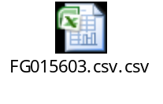

Sample files



